**Netgear Extender Login**

Getting tired with the slow and interrupted internet? Want to get rid of dead wifi spots entirely from your home/office?

What’s better option than installing Netgear wifi extender? When your existing router is not able to provide the stable internet then take it as an indication to add-on Netgear extender at your place.

Netgear extender setup is an answer to all network issues such as slow internet speed, weak wifi signals, poor connectivity, Interrupted internet connection, and more.

If you have an area with disturbed or poor connectivity, then you should install a netgear extender. This article tells you about the basic steps for the Netgear extender login and setup with [**mywifiext.net**](https://mywifiext.net/) web address.

Netgear extender is a device that not only broadens the range of your existing network everywhere but it also makes sure that you get stable wifi signals in all the connected devices. Before we get started, you must check the requirements for the [**Netgear wifi extender setup**](http://new-extendersetup.com/mywifiext-local-setup/).

* The Existing wifi network SSID and password
* Place the Netgear extender in the same room as your router
* You must have the updated web browser installed on your computer

These were some essentials that you must keep in mind before accessing the mywifiext.net setup wizard.

This guide is specially made to help you with the Netgear extender login from the scratch. So, let’s move forward and understand every aspect of mywifiext.net login.

Mywifiext.net is a web address that opens the Netgear extender login page. It is a web page that allows you to install the device, manage access rights, and configure the settings so that you can enjoy uninterrupted signals across multiple devices.

In order to log in to [**mywifiext.net setup**](http://www.netmywifiext.net/)wizard, you would need to follow the below-given steps:

Plug the Netgear extender into a wall outlet and press the power button. Wait till the device turns on and the power LED becomes stable. Now, turn on your computer and go to the Wi-Fi tab and located the Netgear network. Enter the wifi password of the Netgear network.

After you’re connected to the Netgear network, you would need to open up the updated web browser. Type mywifiext.net in the address bar. You will reach to the Netgear extender login page. Provide the default login credentials for your Netgear device. You can look for the default login credentials on the product label or user manual.

When you reach to the [**Netgear extender setup wizard**](http://new-extendersetup.com/), you will be displayed with the available wireless networks. Select your router network from the list displayed and provide the wifi password.

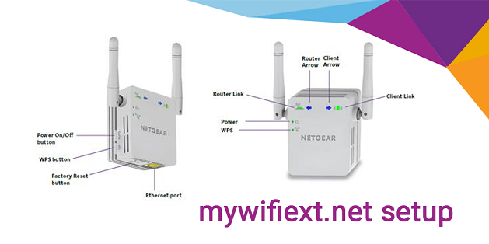

Next, you can configure the wireless and security settings on the mywifiext.net setup wizard. Change the default SSID and wifi password for your Netgear network. It is also recommended to change the login credentials for your Netgear extender.

After completing the Netgear wifi extender setup, you need to click on the ‘save’ option to apply the changes. Your Netgear extender will now reboot and you can place it to a new location. Place it in the middle of the are with unstable wifi signals and your existing router.

Finally, you can connect your devices to the Netgear network and enjoy the extended network. With the above-mentioned steps, you can complete the Netgear extender setup.

Netgear extender login with mywifiext.net helps you extend the existing wireless network. If the process is taking longer than expected or your [**mywifiext.net login page**](http://www.myywifiextnet.com) is not responding, you can always reach back to us. We have a dedicated team that will provide you with troubleshooting methods to resolve such issues.